

American International University-Bangladesh (AIUB)  
**Department of Computer Science  
Faculty of Science &Technology (FST)  
Summer 18_19**

**Online Food Delivery Management System**

A software Engineering Sec: **C** project submitted

By

*MeRaj Rudba (17-34486-2)*

*Fahad Khandoker (17-34800-2)*

*Shahriar Hossian (17-34702-2)*

*Nabil Arman Ayon (17-34765-2)*

The project will be evaluated for the following Course Outcomes

|  |  |
| --- | --- |
| CO3: Choose appropriate software engineering model in a software development environment | Total Marks |
|  |
| Content Knowledge [5Marks] |  |
| Argumentation [5Marks] |  |
| Evidence of Argumentation [5Marks] |  |
| Completeness, Spelling, grammar and Organization of the Answer [5Marks] |  |
|  | |
| CO4: Explain the roles and their responsibilities in the software project management activities | Total Marks |
|  |
| Project Background Analysis [5Marks] |  |
| Project Role identification [5Marks] |  |
| Responsibility Description [5Marks] |  |
| Completeness, Spelling, grammar and Organization of the Answer [5Marks] |  |

Corporate Personnel Name: Rakib Ibna Hamid Chowdhury

Company: Appinion BD Limited

Designation: Software Engineer

Contact Details: +8801833400025

Sign:

**Problem Domain**: Category **B**

**Title:** Food Delivery Management System

**Small Description**: There is a lot of scope online food ordering business and we can tap it to the max extent ordering facility via the internet. Food business usually will have high demand and hence online business prospect for food ordering should be profitable. The customer can register initially with minimum details and will be allowed to check the menu items before ordering them, adding them to cart and submit the order. We are working to develop the already established system of this category to solve some issues we encounter in our daily use. The main goal of our project is to develop a more user friendly and better system.

**Targeted Values:**

* At the current situation we can’t order from multiple restaurant at the same time. As we know one single restaurant doesn’t provide every best items the users want. It will be helpful if we can build a system where user can easily add items from multiple restaurant around the customer at the same time with one single order. We want to upgrade the existing system in a way that, we can have order from multiple restaurant at the same time. We will divide the map into small zones of area where our targeted restaurants will be. There will be a center point for each zone, where our service man can gather. We will have some service person who will collect food from the restaurants and deliver to the center point. Now the orders of a single customer from multiple restaurant will be merged together and our delivery person will deliver the product to the customer as soon as possible. We will select the range in a way that the total process will not cross more than 45 minutes. That is why we are dividing the map into small area so that we can perform this process without any problem.
* At current moment most of the food ordering system doesn’t provide delivery person’s profile. If they had a profile to maintain, they would be more careful with the orders.
* Another problem we face is that, while there is a live tracking of system for the order, it is not consistent. It should be more accurate and delivery time should not cross 30/45 minutes because the food gets cold and customer don’t like to eat that.
* In current situation restaurant keep a written menu with no actual image of the food they provide. If we can make a system where restaurant has to provide the actual image of the food then users will have a clear idea of what kind of food they should be expecting from the restaurant as well as the quantity.
* Another problem we face is that, sometimes customer order something and the food delivery team cancel the order or contact to the customer because the item isn’t available. If we can make the menu more accurate with the actual product available at that exact moment, users will have a more comfortable experience.
* Current review option for the restaurant isn’t strong enough. If we can make the rating of a restaurant more effective than the restaurants will have to maintain their quality to have more orders.

**Conceptual Foundation of the Project:**

**Project Purpose:**

The sole purpose of this project is to improve the existing online food delivery system. The main goal of our project is to develop a more user friendly and better system where people can get the proper idea of restaurants, delivery time and quantity .The system will provide the accurate rating of the restaurants.

**Target Audience:**

Nowadays everyone is having busy schedule whether it is urban area or rural. But talking specifically about the urban areas and deeply about the big cities, people out there are so busy in their life that they don’t get enough of time to have their meals properly.

As these days women are no less than men, in any field. So in big cities even wives are working women, therefore mostly the small families manage to have their food ordered from somewhere, as they lack time.

Not only is this the case, if we talk about the children in the modern era they like only fast food or something from the outside. But they ignore eating homemade meals.

**Software Development Life Cycle:**

We received requirements step by step from the clients along with their feedback. After each iteration the product was delivered to the customers and the customers was provided their feedbacks. Furthermore, feedbacks from the customers were analyzed for better understand the requirements.

The product is delivered step by step (Not at a time). After each sprint a functionality of the product was delivered. Each sprint took 6 days to complete. Changes in requirements were welcomed. If customer wants something to be added or changed then that can be done.

We prefer direct face-to-face conversation with customer. However, they can also use phone, email or project management tools for interaction. We prioritized the requirements as there is deadline. According to the importance of the requirements, the requirements were prioritized. From the above, it can be said that we used one of the agile methods- Scrum for developing our project.

Collecting requirements step by step (through feedback after each iterations) and dynamic environment are the main characteristics of agile development. In addition to these, changes in requirements are welcomed by us and the main goal of the project team was fulfilling customers’ demand. In Scrum method, sprints are iterative cycles where the functionality is developed to produce new increments. The developers deliver features after each sprint and the length of a sprint was approximately 6 days. Customer involvement was very important to us and we worked based on customers’ feedback. The interaction between them was also very strong. A standard team was created and we work together for communicating with each other. The team keeps track of their work progress by arranging daily scrum meeting. All these features clearly indicates that we used Scrum for our project development.

**Software Development Project Roles and Responsibilities:**

**Business Analyst and Project Manager:**

The Project Manager (PM) is responsible for knowing the “who, what, where, when and why” of the software project. This means knowing the stakeholders of the project and being able to effectively communicate with each of them. The Project Manager is also responsible for creating and managing the project budget and schedule as well as processes including scope management, issues management and risk management. In our project **Fahad Khandoker** played the role of Project Manager and Business Analyst. He had the overall responsibility for the successful initiation, planning, design, execution, monitoring, controlling and closure of the project. He defined the project’s scope and determined available resources. He set time estimates and evaluated the team or team’s capabilities. He then created a clear and concise plan to both execute the project and monitor its progress. He was responsible for making decisions, both large and small. He made sure that his decisions would control risk and minimize uncertainty. He used project management software, such as Microsoft Project, to organize his tasks and workforce. These software packages allowed project him to produce reports and charts in a few minutes, compared with the several hours it could take if did it by hand. He called meeting everyday with the team for knowing the daily progress. He developed clear, straightforward plans that stimulated his teams to reach their full potential. He frequently reviewed the budget and planned ahead to avoid massive budget overruns. He identified and evaluated potential risks before the project began. He monitored and analyzed both expenditures and team performance and always efficiently took corrective measures. He had created a report documenting that all project requirements were fulfilled, as well as the projects’ history, including what was done, who was involved, and what could be done better in the future.

### SOFTWARE DEVELOPER:

The Software Developers (front-end and back-end) are responsible for using the technical requirements from the Technical Lead to create cost and timeline estimates. The Software Developers are also responsible for building the deliverables and communicating the status of the software project to the Technical Lead or Project Manager. It is critical that the other team members effectively communicate the technical requirements to the Software Developers to reduce project risk and provide the software project with the greatest chance of success. . In our project **MeRaj Rudba** played the role of software developer. He did the searching, designing, implementing and managing software programs. Testing and evaluating new programs were also done by him. He identified areas for modification in existing programs and subsequently developing these modifications .He wrote and implemented the efficient code. He Developed quality assurance procedures, software tools, processes and metrics. He helped in maintaining and updating the system to ensure that all security problems are fixed, and it operates with new databases. He researched user’s requirements. He designed testing plans for newly developed software. He performed QA testing on software systems. He found faults in software systems and corrected the faults found in software systems. He rewrote the code to correct errors and tested again until code is error free. He wrote the operational manuals and systems specifications. He worked with other staff members such as Project Managers, Graphic Designers, other Developers, Database Administrators, and Sales and Marketing employees. He communicated with clients or Project Managers on the progress of developing software to check for possible improvements, suggestions, or requirements. Then he Wrote reports on project progress.

### SOFTWARE TESTER:

The Software Testers ensure that the software solution meets the business requirements and that it is free of bugs, errors and defects. In the test planning and preparation phases of the [software testing](https://www.atlascode.com/services/software-testing/), Software Testers should review and contribute to test plans, as well as be analyzing, reviewing and assessing technical requirements and design specifications. In our project **Shahriar Hossian Bijay** played the role of software Tester. He was involved in the quality assurance stage of software development and deployment. He conducted manual tests to ensure the software created by developers is fit for purpose and any bugs or issues were removed within a product before it got deployed to everyday users. He met with system users to understand the scope of projects and worked with software developers and project support teams. He identified the business requirements. He monitored the applications and software systems. He carried out stress testing, performance testing, functional testing and scalability testing. He wrote and executed test scripts. He ran manual and automated tests and tested in different environments including web and mobile .He had written bug reports and assessed code. He carried out resource planning and reviewed documentation .He worked towards departmental and project deadlines. He had provided quality assurance and objective feedback to software development project teams. He solved the trouble shoot and problems. He designed tests to mitigate risk. He traveled to different project site.

**TECHNICAL LEAD:**

This person translates the business requirements into a technical solution. Because of this responsibility, it is beneficial to have the Technical Lead involved in the planning phase to hear the business requirements from the customer’s point of view and ask questions. In our project **MeRaj Rudba** played the role of software technical lead. He was responsible for leading the development team, and responsible for the quality of its technical deliverables. He established a technical vision with the development team and works with developers to turn it into reality. Focused on technical matters that affected more than just one developer. He stepped in on heated technical debates, and worked with outside stakeholders to define technical options and agree on solutions for future streams of work. He wrote code with the other developers. He sat with developers, very much focused on moving them towards their goal. He worked to resolve technical disputes, and were watchful of technical decisions that have long-term consequences. He worked closely with the Engineering Manager to build an ideal work environment.

**USER REPRESENTATIVE:**

User representatives have confidence that the development team will work with them to deliver the right solution, even if they didn’t think of every requirement before construction began. . In our project **Shahriar Hossian Bijay** played the role of user representative. He recognized the needs of the consumer and provided detailed information to the consumer about the technical specifications. He helped the customers for getting a proper idea about the system and helped to understand what kind of system they actually wanted to make. He checked that the system is satisfying the customer’s expectation. He provided feedback on prototype and checked all the small releases. Our team moved on next step when he confirmed that the previous part was perfect.

### USER ACCEPTANCE TESTER:

We should expect our software solution provider to carry out a wide array of software testing to ensure that our new software solution meets various quality assurance (QA) criteria. On from that, representatives of the company will need to perform the final checks to ensure that the software works for the business across a number of real-world scenarios. In our project **Nabil Arman Ayon** played the role of software User Acceptance Tester. He checked software solutions before being delivered to clients. His purpose was reducing change requests and consequently, minimizing costs .His main goals were developing testing strategies, selecting testing teams, making sure products are suitable for real-world usage, and documenting test cases.

**UML- Diagrams:**

**Use Case Diagram:**

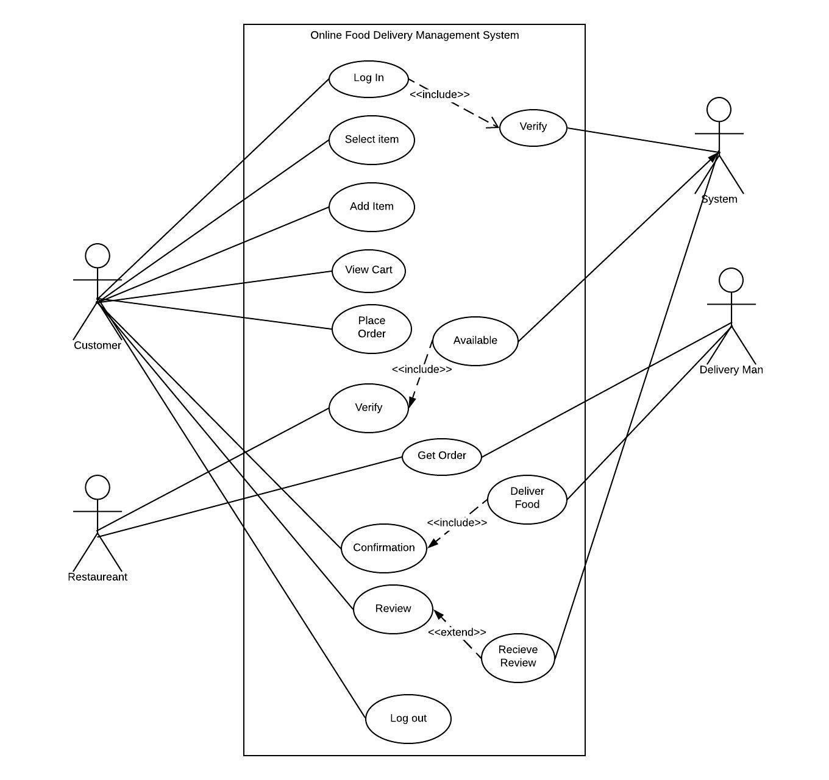

**Class Diagram:**

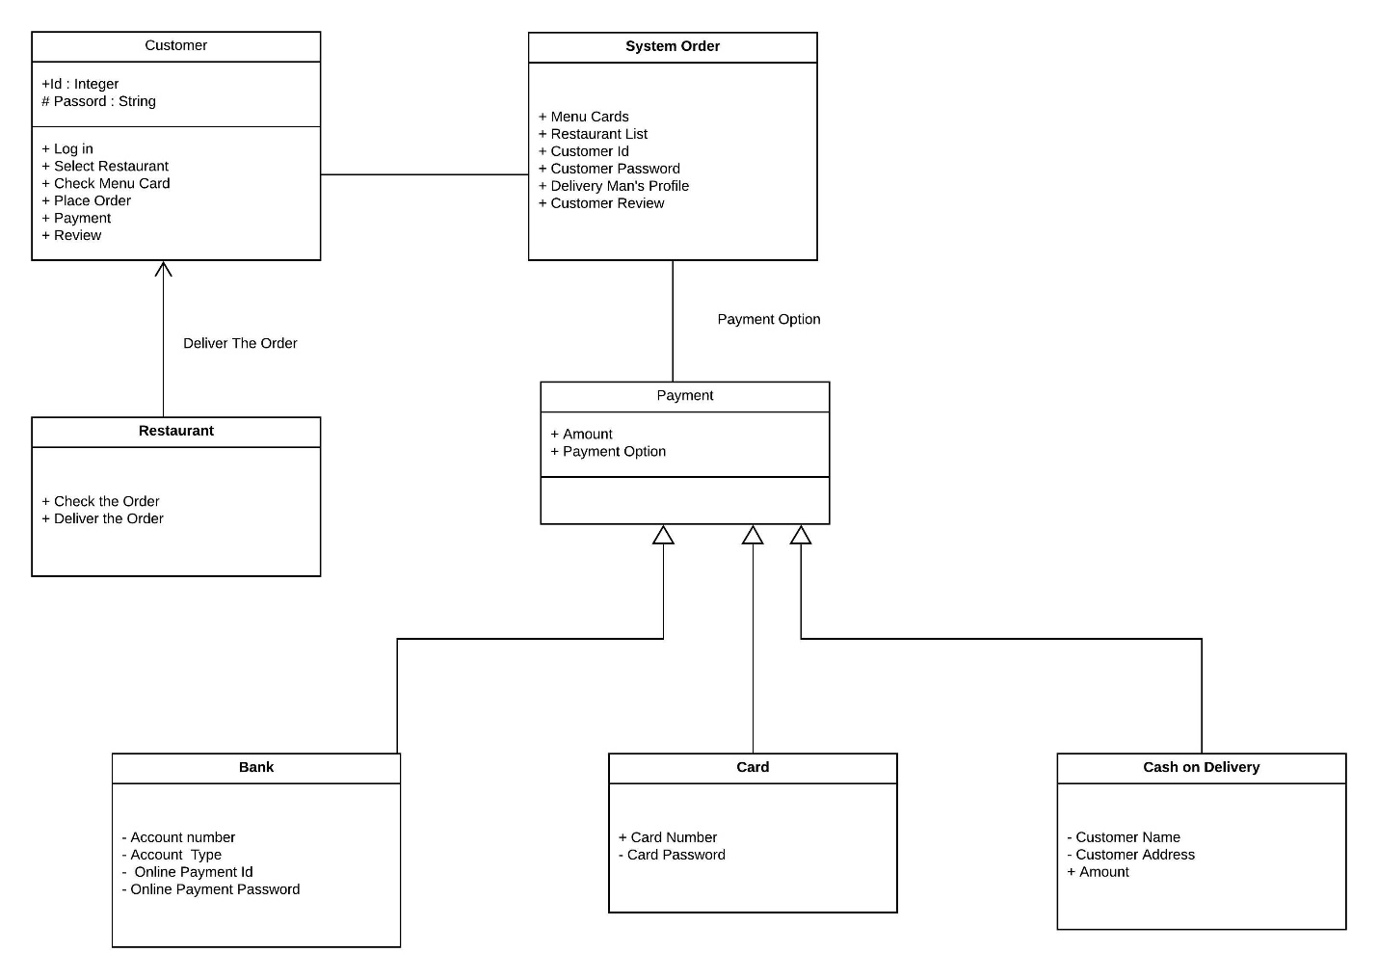

**Activity Diagram:**

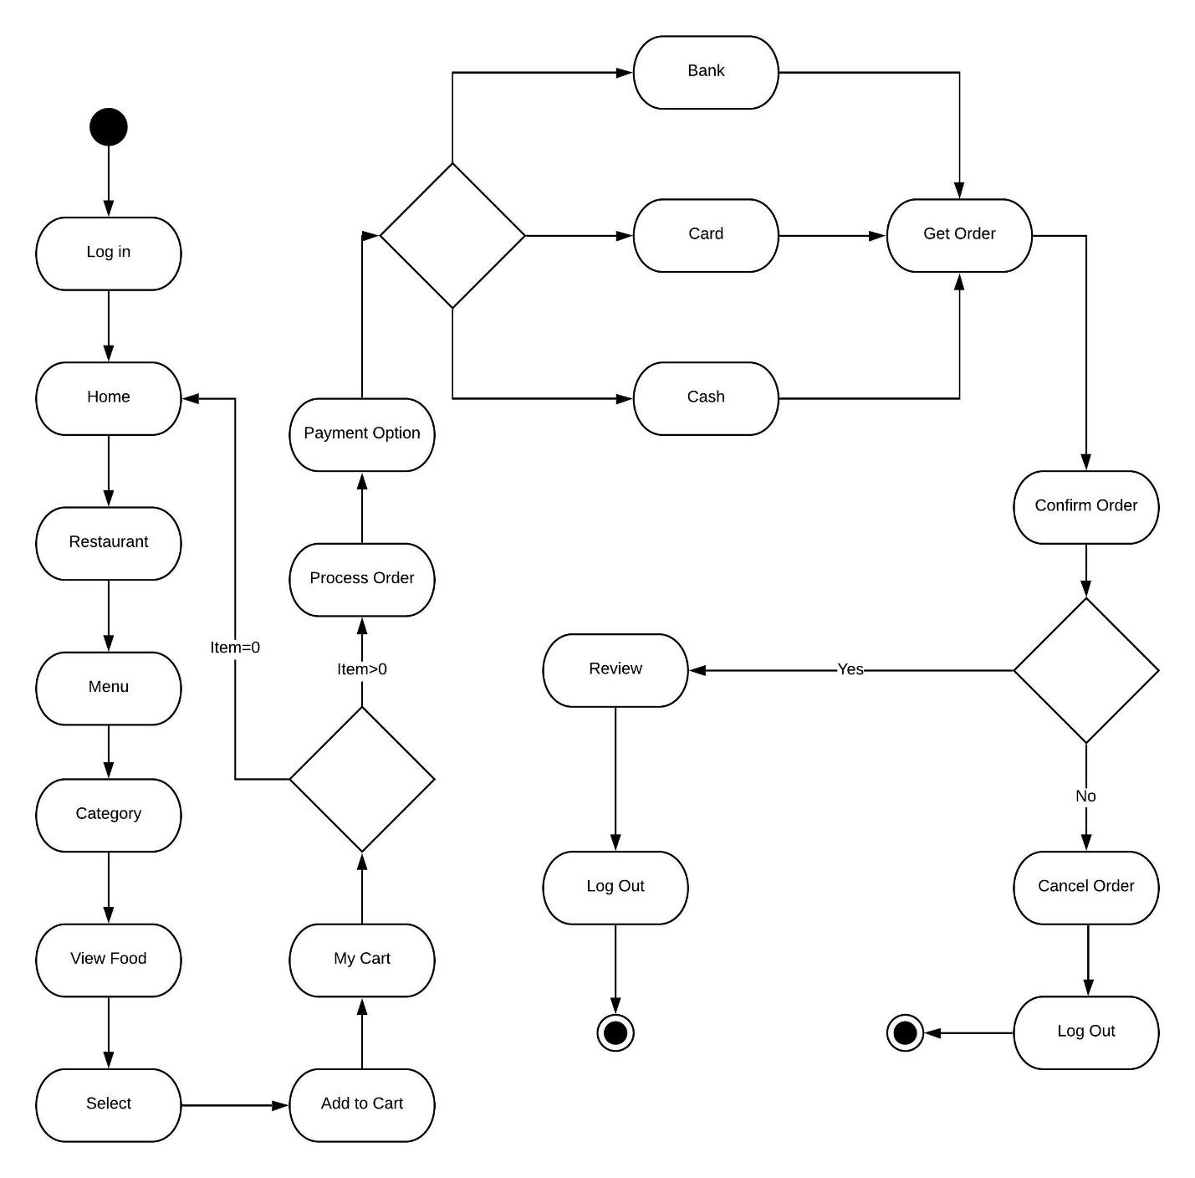

**Scheduling:**

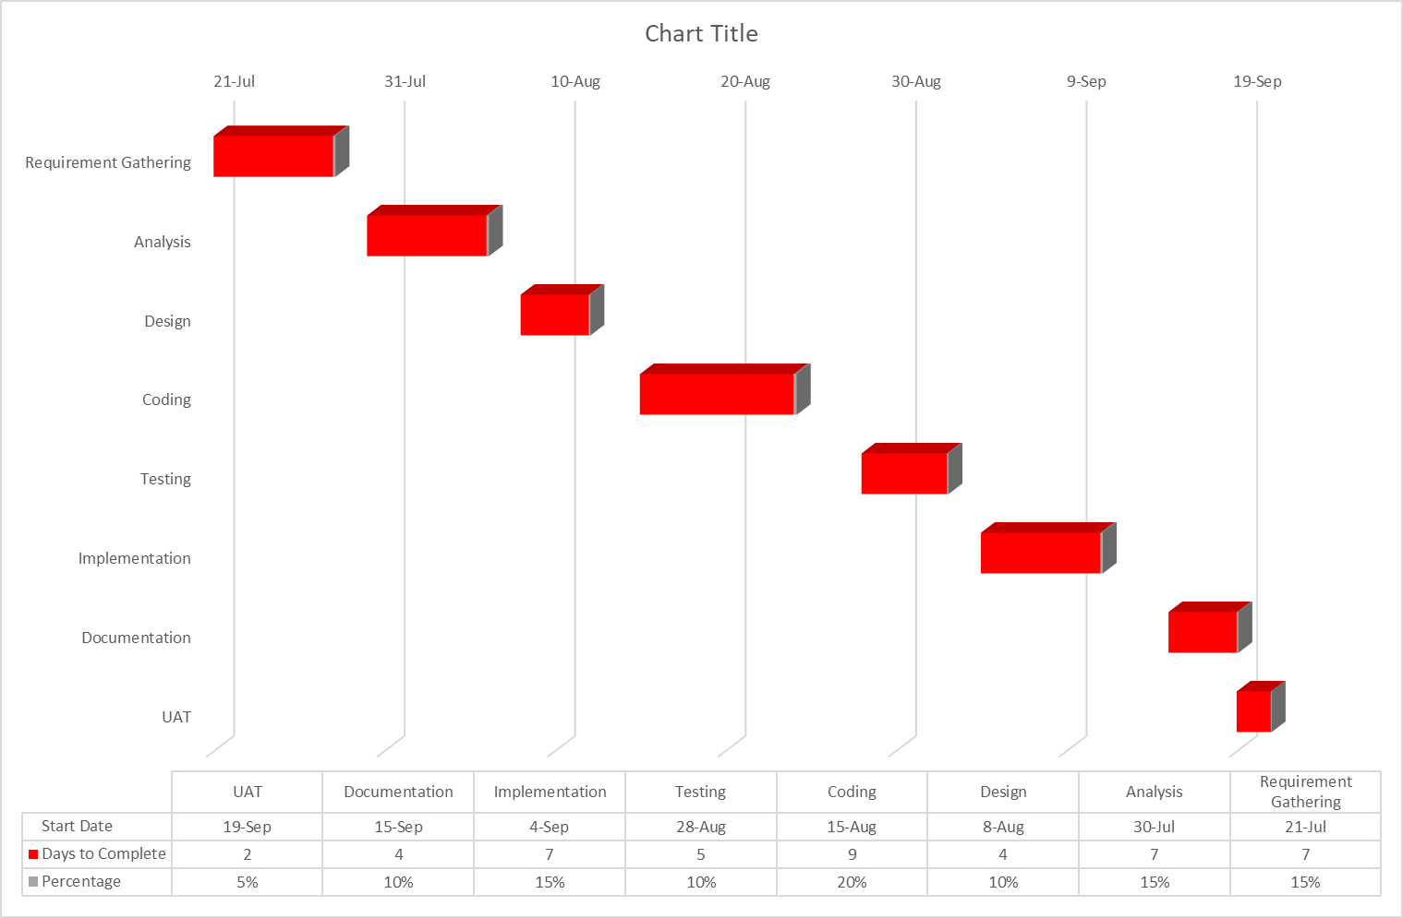

Budget Estimation:

|  |  |
| --- | --- |
| Task | Hours to Complete |
| Requirement Gathering | 56 |
| Analysis | 56 |
| Design | 32 |
| Coding | 72 |
| Testing | 40 |
| Implementation | 56 |
| Documentation | 32 |
| UAT | 16 |

Total Working Hour = 360 hours

Hourly Rate = 1000 taka

Cost = 360*1000

= 360000 Taka

If 5% Discount, then cost = 360000-(360000*5%)

= 360000-18000

= 342000 taka

Maintenance Charge = 200000 taka

Total Cost = 342000+200000

= 542000 taka

**Risk Analysis:**

**Some Categories of risk are listed below:**

1. **Project risks:** Experienced staff will leave the project before it is finished, Essential hardware for the project will not be delivered on time. There will be a change of organizational management with different priorities.

**2. Product risks:** Failure of a purchased component to perform as expected, Size underestimate, Requirement change, CASE tool underperformance.

**3. Technical risks:**

I. Is the technology new to us?

II. New algorithms?

III. Interface with new/unproven HW/SW/DB?

IV. Specialized user interface?

V. New analysis, design, testing methods?

VI. Unconventional development methods?

VII. Excessive performance constraints?

VIII. Customer uncertain about feasibility?

**4. Business risks:**

I. No market for product

II. Product no longer fits in the business plan

III. Sales force doesn’t know how to sell the product

IV. Loss of management support

V. Losing budgetary or personnel commitment

**5. Known risks:**

I. Unrealistic delivery date

II. Lack of documented requirements

III. Lack of software scope

IV. Poor development environment

**6. Predictable risks:**

I. Staff turnover

II. Poor customer communication

**7. Unpredictable risks:** Extremely difficult to identify in advance. They can and do occur.

**Mitigation Plan:**

From a systems engineering perspective, we have listed some common methods of risk reduction or mitigation with identified program risks include the following in order of increasing seriousness of the risk:

1. Intensified technical and management reviews of the engineering process.

2. Special oversight of designated component engineering.

3. Special analysis and testing of critical design items.

4. Rapid prototyping and test feedback.

5. Consideration of relieving critical design requirements.

6. Initiation of fallback parallel developments.